**World Quant University**

**Professor: Steven Stelk**

**Risk Management**

Nikolas Lippmann Pareschi - [nikolaslippmann@gmail.com](mailto:nikolaslippmann@gmail.com)

**Risk Management: Final Project**

**Risk Assessment of Portfolios: Part 1**

* Download data for last 10 years for all the 30 stocks of the Dow Jones Industrial Average (ignore survivorship bias, and unless you have access to a point-in-time database, simply download the data for the current set of DJIA index constituents.)
* In addition, download data for Futures contract of the DJIA for the same period of time (consider the nearest month contract always)
* For each of the cases outlined below, (unless specifically mentioned) randomly select a basket of 10 stocks from the list and create an equal weighted portfolio with a total value of 10,000$ invested all together at the beginning of the period under questions. Risk-return profile calculations should include calculations for the following KPIs –

                                    i.    Average Monthly Return,

                                   ii.    Percentage of Positive Months,

                                  iii.    Average Yearly Return,

                                 iv.    Max Monthly Drawdown,

                                   v.    Max Drawdown,

                                 vi.    Lake Ratio &

                                vii.    Gain to Pain Ratio

The used the data provided by the professor in Piazza for options and for stocks. But as they are not from the same period, the first step was to make them of the same period. I opted to use the data provided and not to download as requested because panda datas reader is facing some problem since last changes in yahoo.

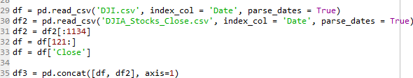

I used also the class provided for the KPIs computation. I made some plot also to improve our analysis:

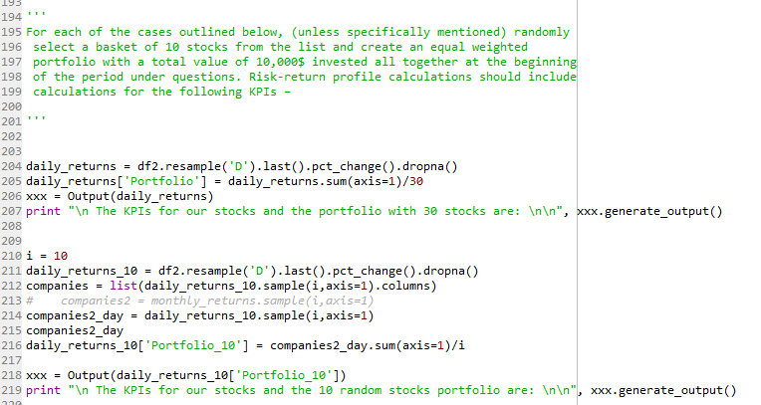

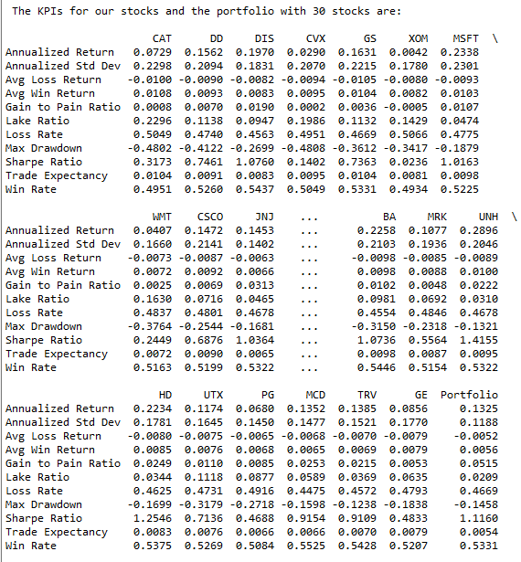

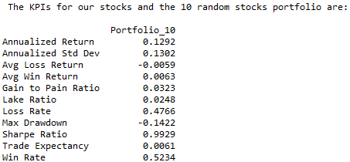

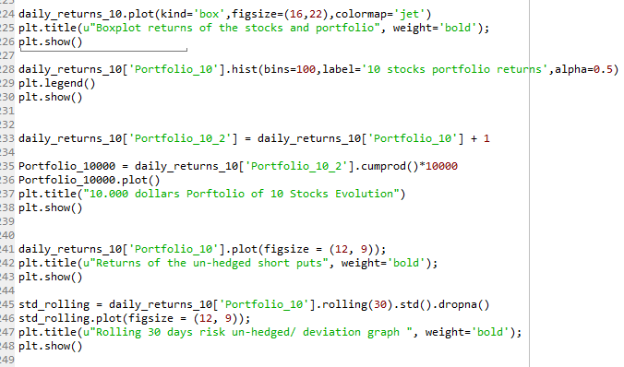

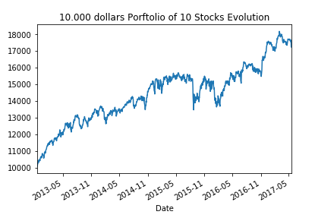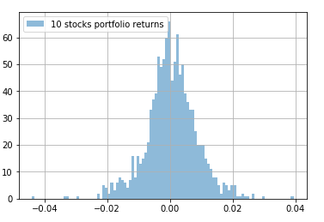

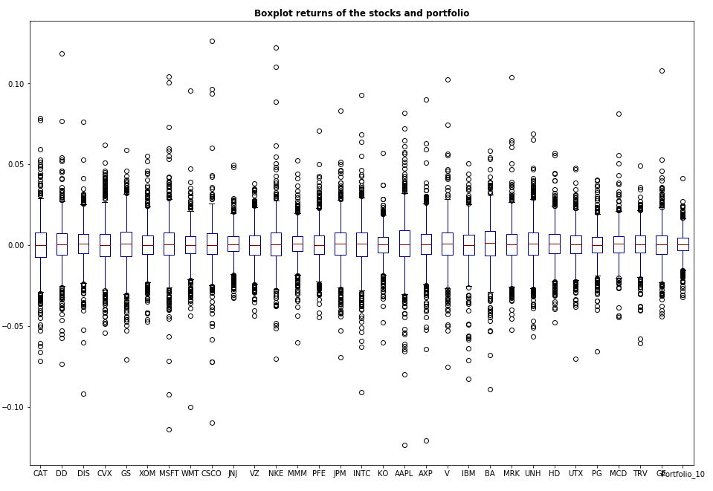

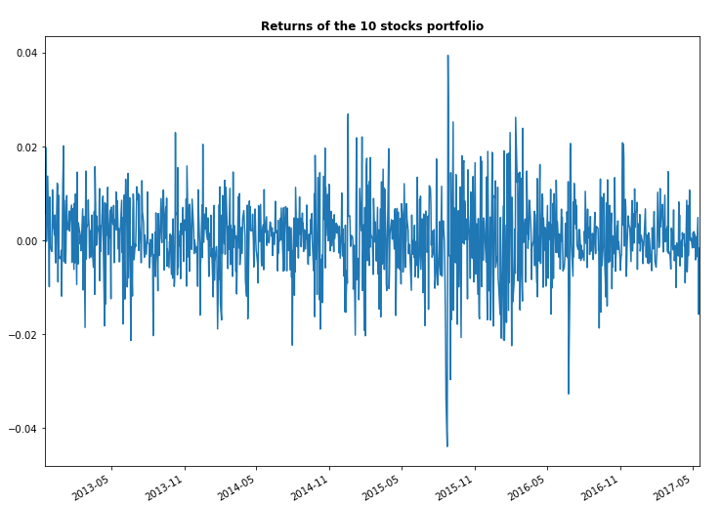

                  ii.       **Risk Management by Stop Loss:**

                                    i.    Estimate the risk-return profile of such a long-only portfolio over the period of last 10 years. Put special emphasis on analysis of the response of the portfolio to negative price shocks.

                                   ii.    Now consider a modified portfolio, where position in any stock is fully liquidated if the price drop 20% from its nearest 6-month high and its position is filled by another randomly selected stock from the rest of the group.

                                  iii.    Estimate the risk-return profile of such a modified portfolio over the same period. Compare and contrast the results with the simple  long-only portfolio

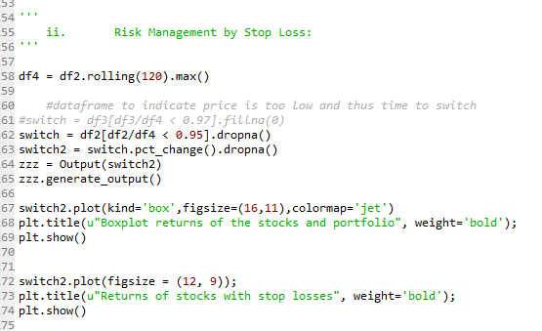

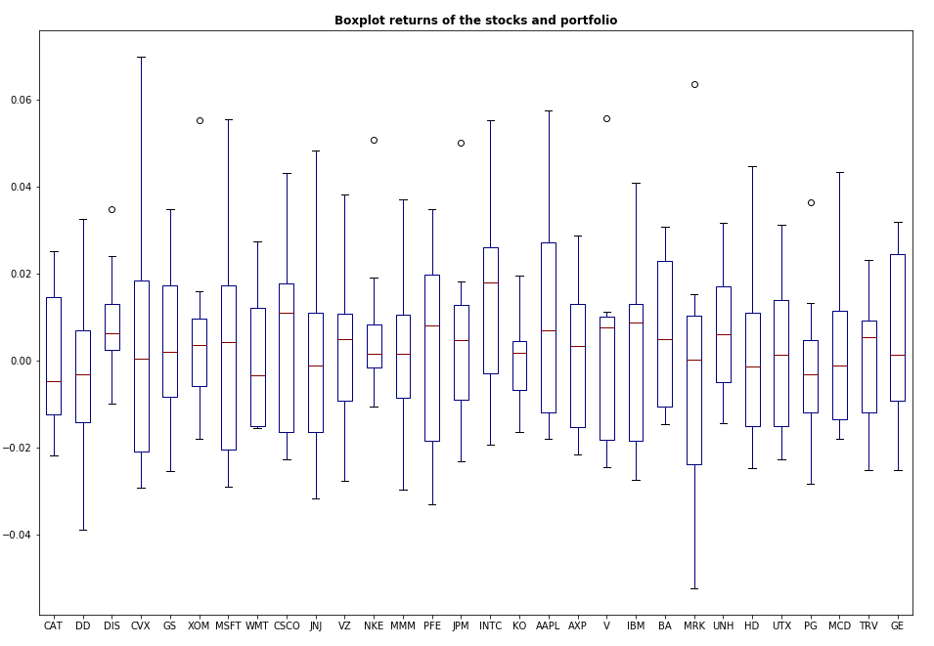

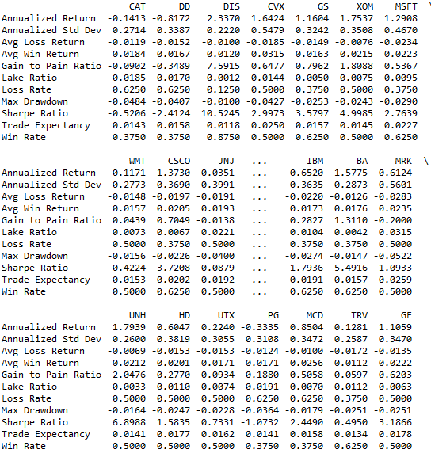

                iii.       **Risk Management by Hedging:**

                                    i.    Take the long-only portfolio discussed in step (i) of “Risk Management by Stop Loss” and its risk-return profile as a base.

                                   ii.    Now consider a modified portfolio, where the overall long position of the portfolio is hedged with a net short position in the DJIA index amounting to about 10% of the overall long portfolio size. As a rough estimate you can construct the long-only portfolio on 9,500$ and use 500$ as the margin money to short the DJIA for a overall position of 950$ short.

                                  iii.    Estimate the risk-return profile of such a modified portfolio over the same period. Compare and contrast the results with the simple  long-only portfolio. Put special emphasis on analysis of the response of the portfolio to negative price shocks.

Code:

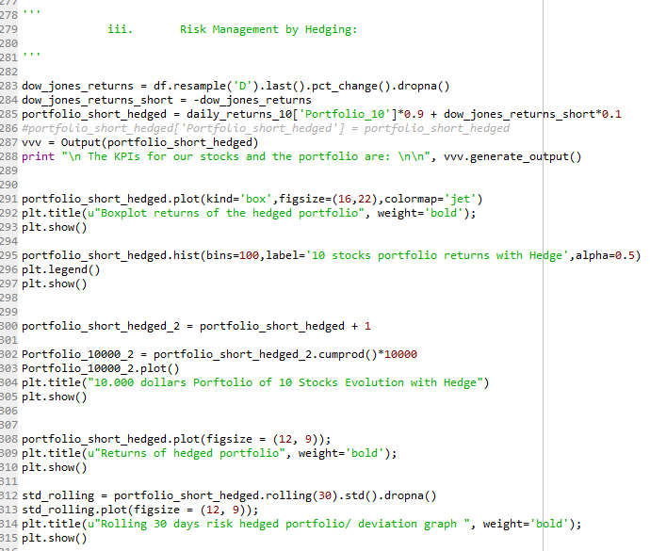

Results:

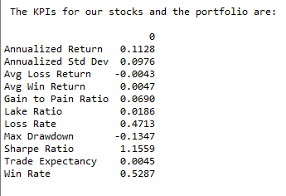

We have observed that this portfolio hedged had lower drawdown. It had a 13,47% drawdown against a 14,48% drawdown of the unhedged portfolio . We had also a improvement in the sharp ratio (1.1559 x 1.1160.) The annualized return was lower nevertheless (11,28% x 13x25%)

This is the old unhedged portfolio:

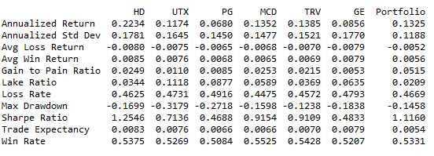

Some more graphs:

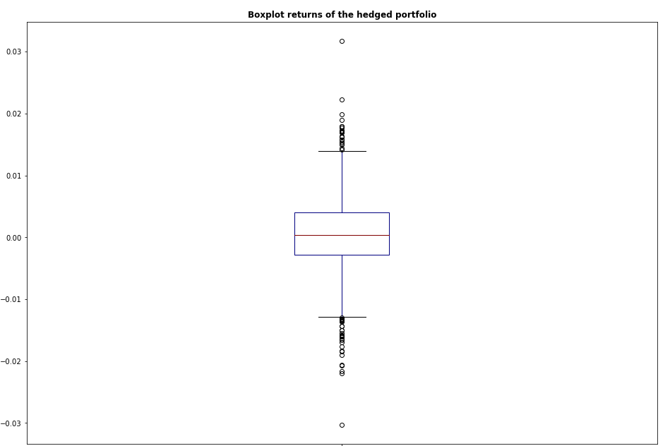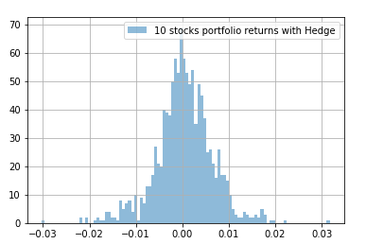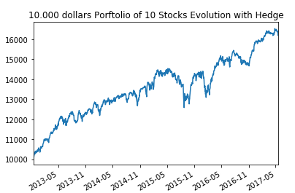

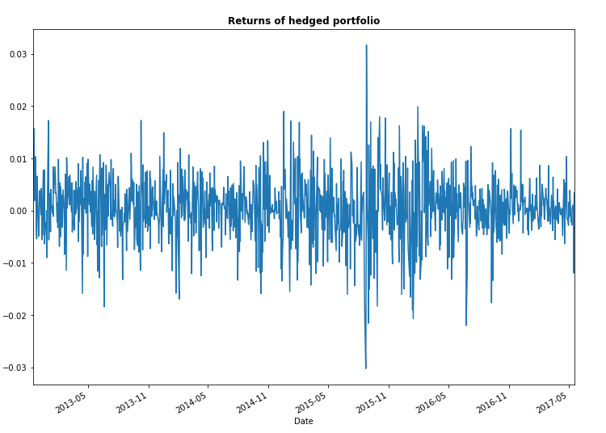

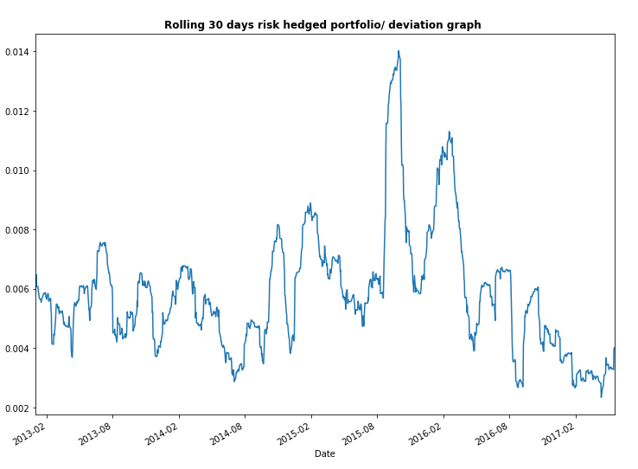

**Risk Assessment of Portfolios: Part 2**

The second part of this project builds on the work done in the first part and adds new complexities to the portfolio design and analysis of risk mitigation mechanisms.

            i.    **Risk Mitigation by Diversification & Non-Correlation:**

                                    i.    Take the 10 stock long-only portfolio discussed in step (i) of “*Risk Management by Stop Loss*” and its risk-return profile as a base.

                                   ii.    Now consider 4 more modified portfolios consisting of a randomly selected basket of 15, 20, 25 & 30 (all the stocks of the DJIA) stocks.

                                  iii.    Estimate the risk-return profile of such a modified portfolio over the same period. Compare and contrast the results with the simple long-only portfolio.

Code: 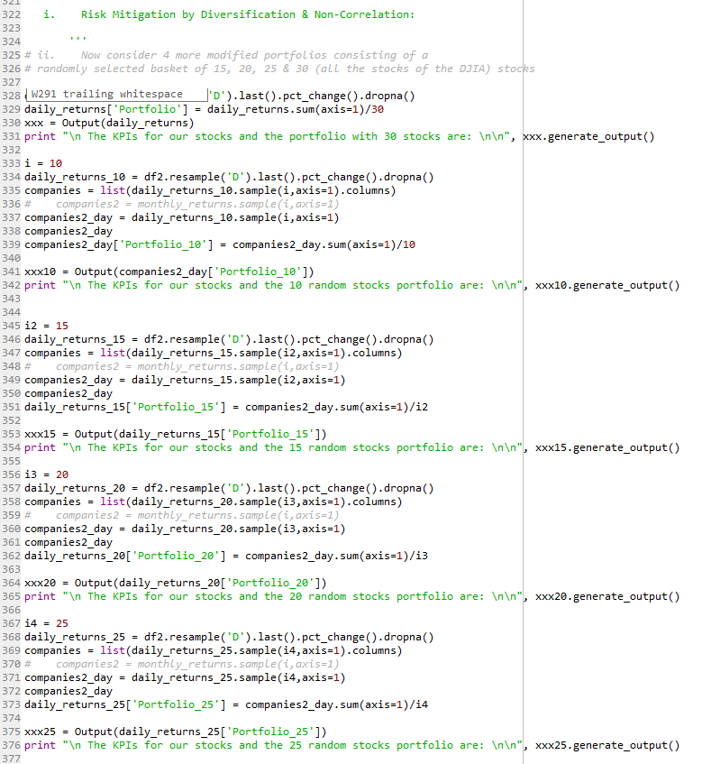

Results:

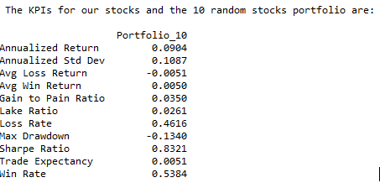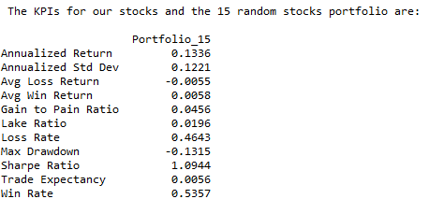

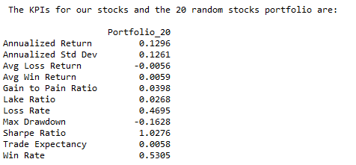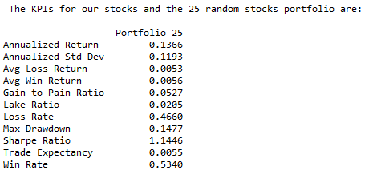

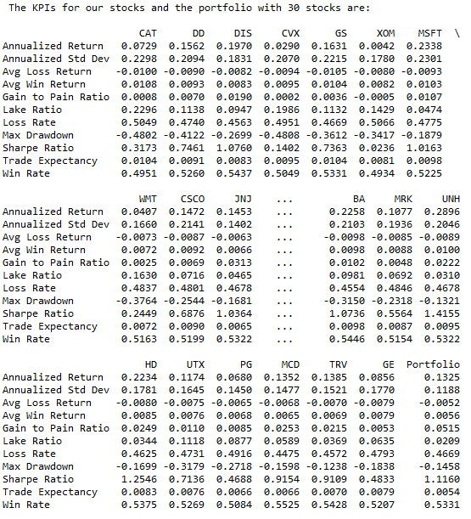

Comments: We see that the increase of diversification made in every case a higher sharp ratio. Regarding the drawdowns we were not able to see any relevant pattern.

                                 iv.    Analyze what percentage of the initial market-risk in the 10-stock portfolio was successfully “diversified off” by randomly increasing the portfolio size at each step and any other improvements in the overall risk-return profile. Based on the results, comment on whether diversifications work beyond a point.

We had an increase of 28% on the sharp ratio. Curiously, our drawdown was also higher. Probably we got a good random 10 stocks portfolio without outliers.

                                   v.    Now redo steps (ii) to (iii), but this time do not randomly select stocks. Based on the 10 stocks initially in the portfolio, isolate the remaining 20, calculate their historical return correlation (for time before the 10 years in question – download data for at least 3 more back years for this) and rank them according to highest non-correlation to the overall portfolio under question. Now add stocks in their order of non-correlation to the initial 10 stock portfolio to create 4 new portfolios of size 15,20,25 & 30 respectively

                                 vi.    Analyze what percentage of the initial market-risk in the 10-stock portfolio was successfully “diversified off” by specifically adding non-correlated assets to the portfolio. Based on the results, comment on whether diversification through addition of non-correlated assets work better than simple random diversification as observed in step (iv)

Code:

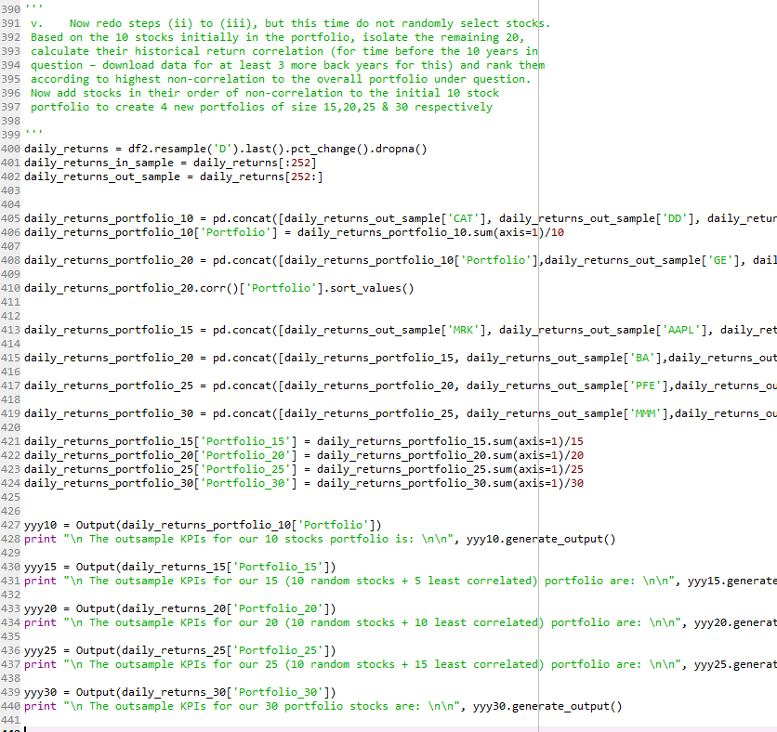

Results:

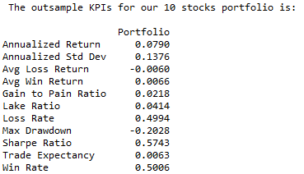

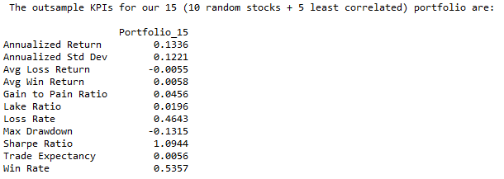

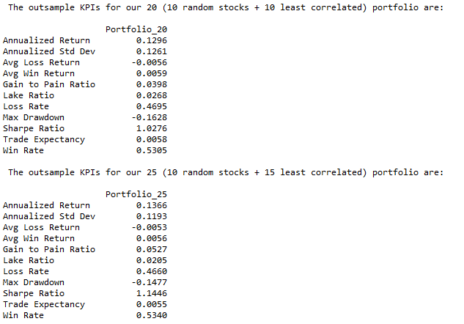

We can observe a great increase in the sharp ratio and a high decrease in the drawdown with the adding of the uncorrelated stocks, considering ONLY the out sample. This is very impressive and the results are linear, as we add more stocks the results deteriorate. So it is better to select uncorrelated stocks than to just add blindly stocks (huge number).

          ii.   **Risk Analysis of Options Portfolios – The Theta Decay Benefit:**

                                    i.    Download relevant Options data for DJIA – consider the earliest expiry Call Options contract that is 4 strikes Out of the Money. If liquidity is extremely less in that particular strike, consider the 3rd OTM strike

                                   ii.    Take the 30 stock long-only portfolio discussed in step (ii) of “*Risk Mitigation by Diversification & Non-Correlation*” and its risk-return profile as a base.

                                  iii.    Now consider a modified portfolio that tries to benefit from the Theta decay of options and generate a safe income on its long-holdings ( a slightly altered covered call scenario). With a long position in all the 30 stocks for DJIA, sell an equivalent amount of Out of the Money Call Options to generate an X% cover. Vary X between 50%, 75% and 100% - thus considering 3 scenarios overall for the covered portfolio.

Considering the fundamental theorem of options we have that:

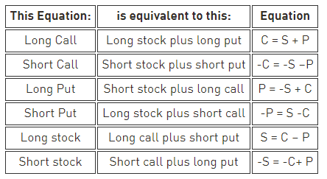

<https://www.tradingacademy.com/lessons/article/option-equivalents-six-one-half-dozen/>

So the problem described is the same than being short the put with 4 strikes OTM.

Code with adaptations:

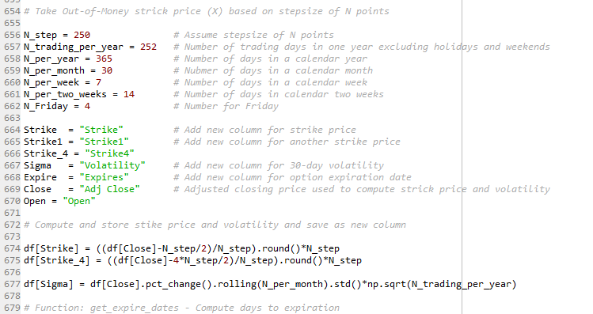

I made some adaptations in the code provided in piazza, so we could have 4 strikes OTM considering the Close Prices.

                                 iv.    Considering the premium obtained from Option Selling (and occasional losses due to exercise) and the returns of the portfolio each month, estimate the risk-return profile of such a modified Options portfolio over the same period. Compare and contrast the results with the simple long-only portfolio of 30 stocks.

As described above, if we compute the returns of the short put portfolio we will be long the instrument with a covered call, having all the theta from the covered call in our favor.

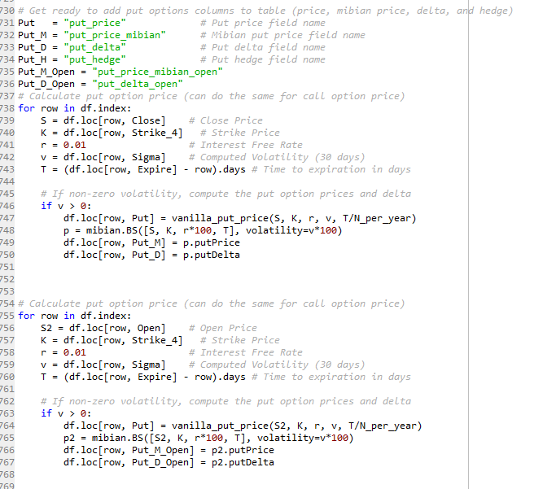

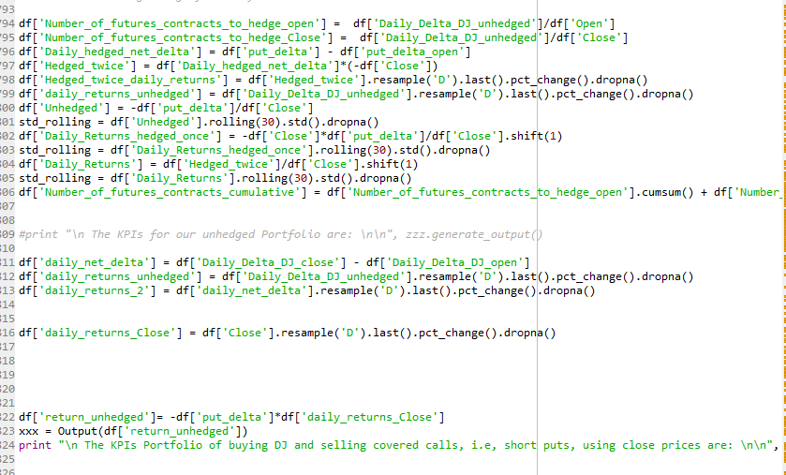

Results:



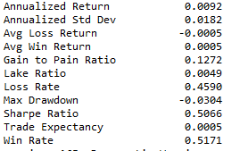

                                   v.    Based on the results, comment on whether adding a pinch of Short Options positions to a overall diversified long portfolio can produce significantly better risk-return profiles than standard diversified portfolios.

We have a max drawdown much lower than the standard one. In part that is from the fact that the algorithm only considered one month, but I part that is also from the premium collected from the covered call. The theta collected will imply in a lower drawdown. It can imply nevertheless in a lower return, but not necessarily.